Team A – Tank Wars
Customer Requirements Report

September 5, 2014
John Aromando
Mike Bunger
Leah Austin
Jason Rivera

Procedure
Our team’s approach to gathering Customer Requirements data was designed to introduce the game as if the customer had purchased it and started playing alone. There was no help or explanation given in round one, and no questions were answered. Round two, the player’s questions were answered and any undiscovered features, such as fire strength or movement, were explained.
Round 1
- Players were asked to play the game
- We refused to explain or provide answers
Round 2
- Players were asked to play another round
- This round, questions were answered and the players were given an explanation of undiscovered features

During the two rounds, the player’s responses, questions, bugs, suggestions, access to the help and options screens were noted. Each round was concluded when the player completed the game or demanded to stop.

Data Gathered From User Experience
Demographics of Users:
Number of participants: 11
Average Age of participants: 27
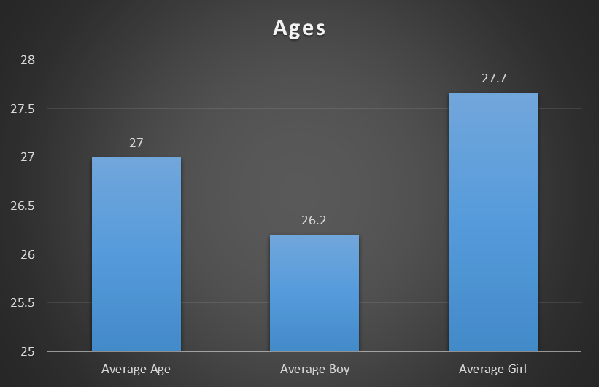
Gender: 45% Male & 55% Female
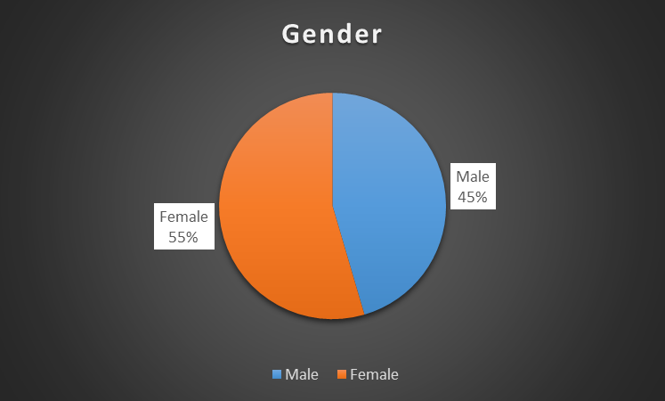

Experience: 55% Novice & 45% Expert
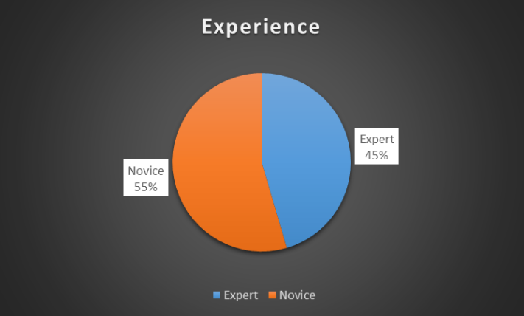
Based on the overall experience, the following bugs were discovered.

New Bugs Discovered

Bug Name | Descriptions | Severity
Space Bar | The space bar stopped firing | Severe. A restart was required.
Frozen Game | Everything stopped moving and nothing worked. | Severe. A restart was required.
Tank Off Screen | Tank rolled of screen and could not be recovered. | Severe. A restart was required.

Strengths & Weakness of the Software

Strengths:
Music was overall liked
Extras and Weapons
Player success after time
Randomization of level when restarted
Weakness:
Confused about controls
Not user friendly
Screen transitions
Poor Help Menu/Tutorial
Comments:
After player ended the game -“I would recommend this to a kindergartener.”
As the novice player started - “How do I win?”
After multiple rounds of playing two players - “I like it now, I’m winning!”
While playing through the first round - “If I kill myself, would that be acceptable”

Observations:
Novice player would shoot up at herself to end the game quickly.
More confidence as the player progressed.
Players did not know the tanks could be moved.
Plans for the future
After the overall experience, the team plans on improving the tutorial menu, bugs that were stated in the earlier chart, make the software more user friendly and polishing the software to make it a smoother experience.

