Team A – Tank Wars
Program Review Report

John Aromando
Mike Bunger
Leah Austin
Jason Rivera

Installation

The installation and setup process provided a few errors when attempting to get the game running. As detailed by documentation, the user is directed too:

- Download and Install the Eclipse IDE for Java EE Developers
- Import Tank Wars into Eclipse.
  - Unzip Tank Wars.zip to a folder
  - In Eclipse Go to File > New > Other > Java Project
  - Uncheck Use default location.
  - Click Browse and select the “Code Repository” folder.
  - Click Finish.
  - Click green play arrow to run and use game.java
  - If it asks: have it run as an Application.

The team implemented these instructions and received:

<Data.txt>: File not found
Exception in thread "main" java.lang.ExceptionInInitializerError
Caused by: java.lang.NullPointerException
at DataClass.readFile(DataClass.java:37)
at DataClass.<init>(DataClass.java:21)
at Game.<clinit>(Game.java:48)

There was a troubleshooting section, but that did not help with the teams issue.

While issues did persist when using Java 8, addressing the game through the windows command prompt on lesser versions got the game running. Simply navigating to the src directory (e.g. Tank-Wars-Code-Repository\Tank Wars 2012 Team B\src) and typing in java -cp . Game prompted accessibility to a fully work Tank Wars game.

Java 8 Fix
If you have Java 7
Update to Java 8
If you have Java 8 or No Java
- Go here http://www.oracle.com/technetwork/java/javase/downloads/jdk8-downloads-2133151.html if you don’t have Java Developer Kit and Download it.
- Go to the Control Panel > System and Security> System> Advanced System settings

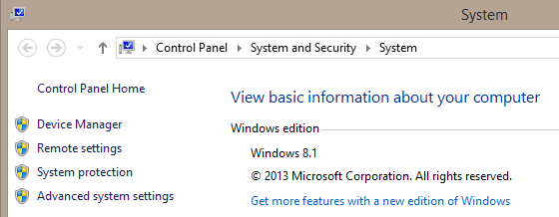
- This should pop up. Click on Environment Variables
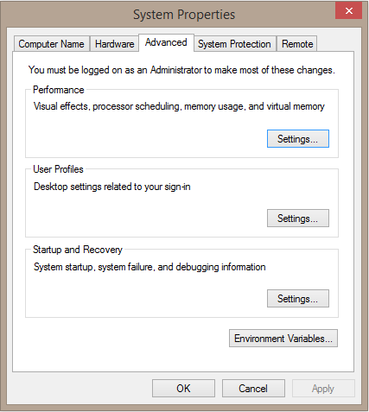
- Click on the Advanced tab. Click on PATH and then Edit…
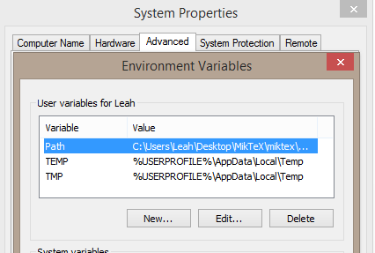
- In the Second input box, you need to type the address of where the new installed Java 8 is. This is usally found in the control panel with this adress but will Vary dependingon the computer.

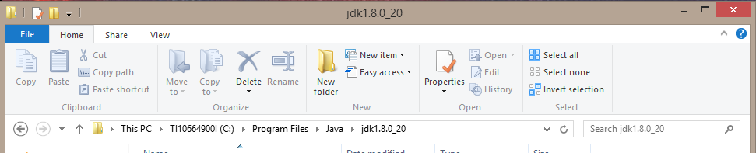

- Right Click this address, Copy and paste into the Second input box and click ok.
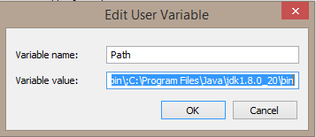
- On the command prompt, go to the file where Tank Wars is kept and type in Javac *.java
- An Error will appear.
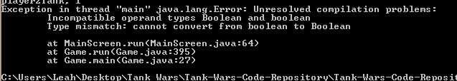
- Go to Main screen.java lines 24 and 25. Turn Boolean to boolean. Save
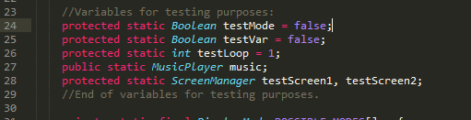
- Recompile and run the game.
- Java 7 won’t stop this error but Java 8 will.

Overview

The players are first introduced to the start menu. It is a simple screen that gives the ability to start or exit the game along with a help menu option. In this help menu, players can find all detailed instructions on how to operate the tank and alter game features.
The games interface is very basic, but effective. The health bars are displayed in both of the upper corners of the screen. These are also labeled with their respect player number. Weapons the tank is currently using is shown just below these health bars. The weapons can be changed, each one having a different effect. The wind speed and direction is available to view on the top of the screen as well. Lastly, the power bar is displayed below your tank and can be increased or decreased.
The interface displays a way to see another type of help menu called "Options". Inside "Options", the player can restart the game, adjust the wind by turning it on or off, and change the music. It also features another set of instructions similar to those found in the help menu.
A tutorial is available on the games interface as well. This goes over how to move the direction of the tanks aim and how to change the tanks weapons. The tutorial is probably the weakest part of the game as it does not accurately portray how to change the weapons or how to change the tanks power.
Overall, Tank Wars is a turn-based game in which the player is trying to destroy the other tank before it destroys them. It provides a lot of option and choice for the players as it can be customized to a certain degree. Terrain is randomized and can be destroyed when hit by bullets, forming craters. The controls are very simple and easy. There is also music the plays throughout the entire game and adds a lot to the different menus and actual game play. Once the game is finished and a winner is declared, the winner rides off and credits pop up once the players press escape.

Bug Report
Name Of Error | Description | Severity of error | Documented
Incompatible Operand Type | In the Mainscreen.Java, Boolean was used instead of boolean. | Very severe. Cannot run game with Java 8 until fixed | Undocumented
Main Screen to Game Screen transition | Sometimes shows the desktop when transitioning from the main screen to the game. | Mild. Doesn’t affect game play | Documented
Power on Restart | When the game is restarted, the tanks are unable to damage each other. | Severe. Game cannot be restarted without exiting | Documented
Missed turns | Sometimes a player’s turn will be skipped. | Medium. Can affect game play | Undocumented
Tank Moving after Reset | A moving tank will continue moving even after the game reset. | Medium. Screen will reset before game will continue | Undocumented
Music Overlap | The credit song will start to play after a game reset | Mild annoyance. Doesn’t affect game play. | Undocumented

Documentation
Document Name | Description | Recommendations
Code Read-Me | This file contains a detailed description of the game including the main screen, help screen, pause menu, and the game itself by explaining different options available. | Can be helpful when playing the game but can be more detailed.
Read Me First | This file list the order in which we should read the other files. | Useful for looking at the order of the files but can be more detailed.
Scrum Cycle Info | This file contains how the previous team was managed by describing teaming meetings and how work was divided. | Will be very helpful to maintain an efficient group. This file will become a mutable guideline for the team to follow.
Tank Wars Bugs, Potential Features | This file describes five documented bugs and what causes them and when they happen. A list of nine recommendations to improve the game are listed here as well | This file will be useful to help the team debug. All documented bugs can be worked on accordingly to the teams priorities.
Tank War Installation and set up | This File describes how to Install the game to Eclipse with a quick step by step instructions. This is followed by a detailed description of SVN and how to set it up. | Gives the user general information on installation. Can be worked on for further detail.

Discussion
Top Priority Issues | Recommendations
Screen transition cause program to exit to desktop, then pops back into the new screen. A more smooth transition is favorable. | The team will first look into the code to find the cause of the issue and work together to find a solution.
Pressing the “r” button will reset the match, change the terrain, and produce a new song. Resetting should not change terrain and music. | Replace the code that changes the terrain and music to repeat what it originated as.
If a tank touches the left edge of screen, a “Hersco Bomb” will drop along the left edge when the turn ends. This does not occur when a tank touches the right edge of the screen. | Use the code for the Hersco Bomb on the left side to write up a solution to the right side.
The “Hersco Bomb” is a homing bomb dropped by a jet, but another shot may be fired while the jet is traveling to the enemy tank. | Make it so that no actions can be taken when the Hersco Bomb is coming.

Minor Issues | Recommendations
The “Joker” bomb has an odd hit box and a poor texture. | Replace the hit box to fit properly.
Many situations bring overlapping music. For example, winning then restarting while the tank traverses terrain. | Replace the music to fit properly.
Tanks cannot shoot completely horizontally. | The team will rewrite the code to make it possible to shoot straight across.
The first initialized match randomly places the tanks on the left and right side, when resetting places them equal distances from the center. | One solution can be to rewrite the code so the tanks always appear at the same spots when restart is pressed.
Resetting the match will reduce ammo to one or two for special weapons, when the first match provides 50 for each. | When restart is pressed, make it so the round is how the game originated as.

